Moving files between Cyberark server and VDI system via WinSCP

created by Harsh Verma

Purpose: This documentation deals with moving files from Citrix VDI to Cyberark Server (master or FG, both QA and PROD).
The steps use a text file as sample in production server of Windchill NA:
Server used: rwl-wc11bg-p01.dc.fmcna.com
Additional Information regarding the hostname:
- HAL stands for Hartwell Ave Linux (Non-Production)
- RWL stands for Reservoir woods Linux (production)
Steps to follow:
- Login to CyberArk North America URL & search the desired server to connect to -
Note: Complaints loading is done in master node of Production Server only)
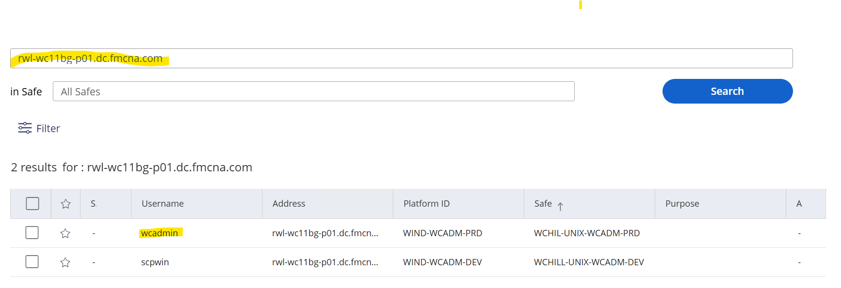
- Select the result with ‘wcadmin’ username.
- Go to target server (here we are using prod master as example: rwl-wc11bg-p01.dc.fmcna.com)
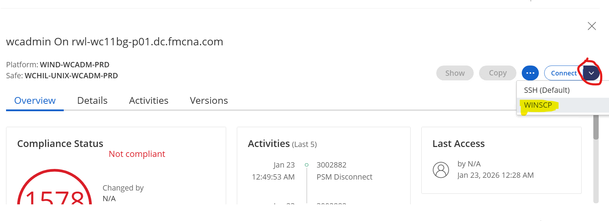
Note: We can also connect to ‘scpwin’ in case wcadmin winscp connection doesn’t work.
- Open WinSCP to move physical files from remote server to local VDI.
- While connecting to WinSCP, select option Map Local drives.
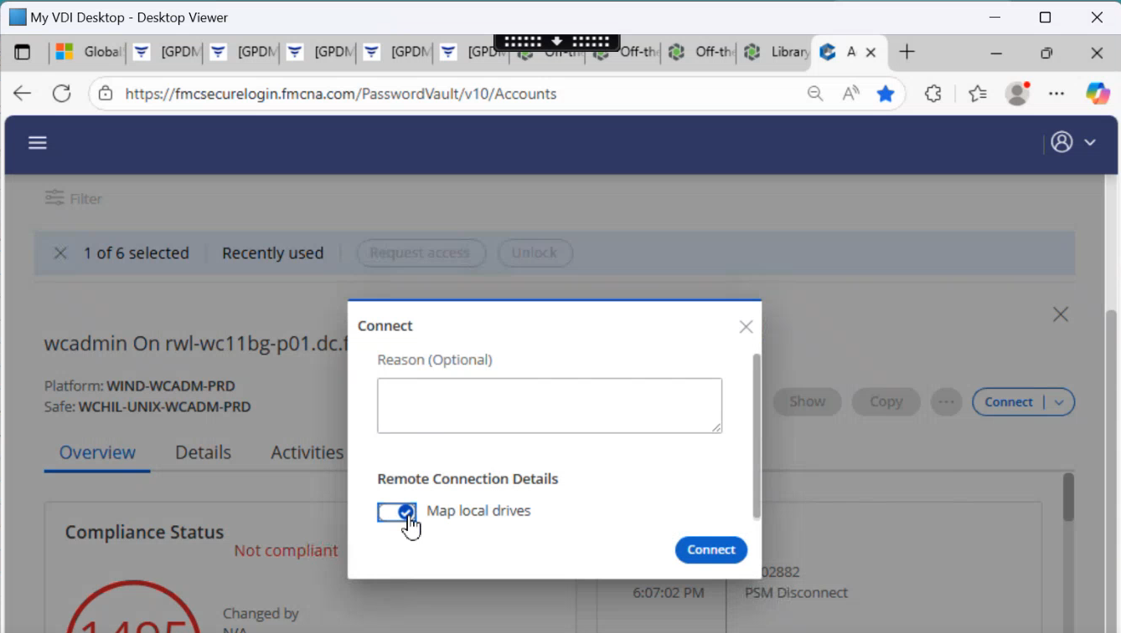
- Click Connect button to Open WinSCP in selected configuration.
- On left side we can find option on dropdown which maps to our Citrix VDI.
- To add files of our file system, click the dropdown on top left.
- Go to Z drive on dropdown.
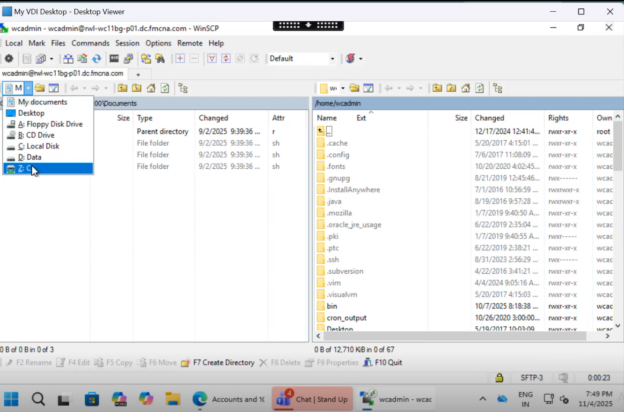
- For ease of use directly navigate to Z:/Users/<ZID>
- Here we are importing a file (windchill-11-04-2025.txt in this case) from our local system to the cyberark master node.
- Now, we can use copy option via right clicking the file or we can click the file and use f5 shortcut key to copy or simply select, drag & drop from left to right panel (make sure path is where we need to copy to)

Note - Similarly, we can follow the steps below for remote to local (i.e. right to left panel)
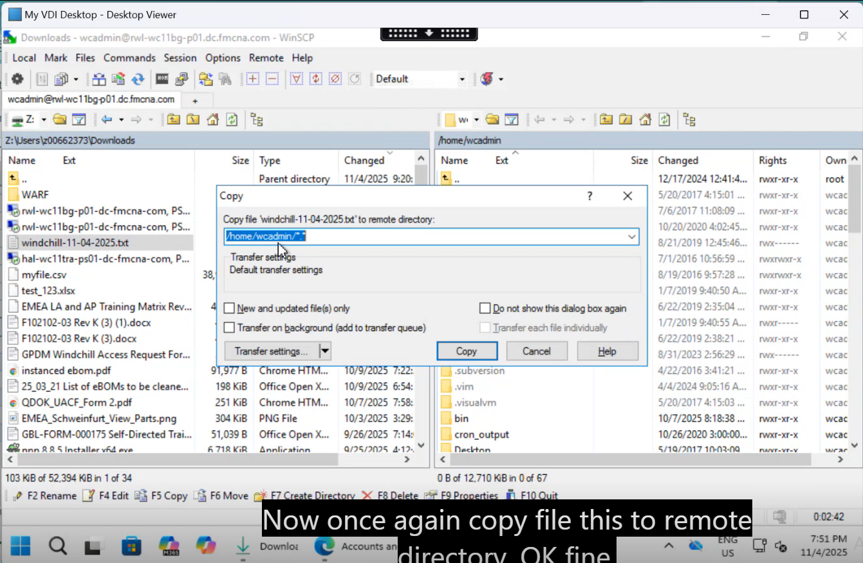
- Once copy button is clicked the file gets copied to remote server.
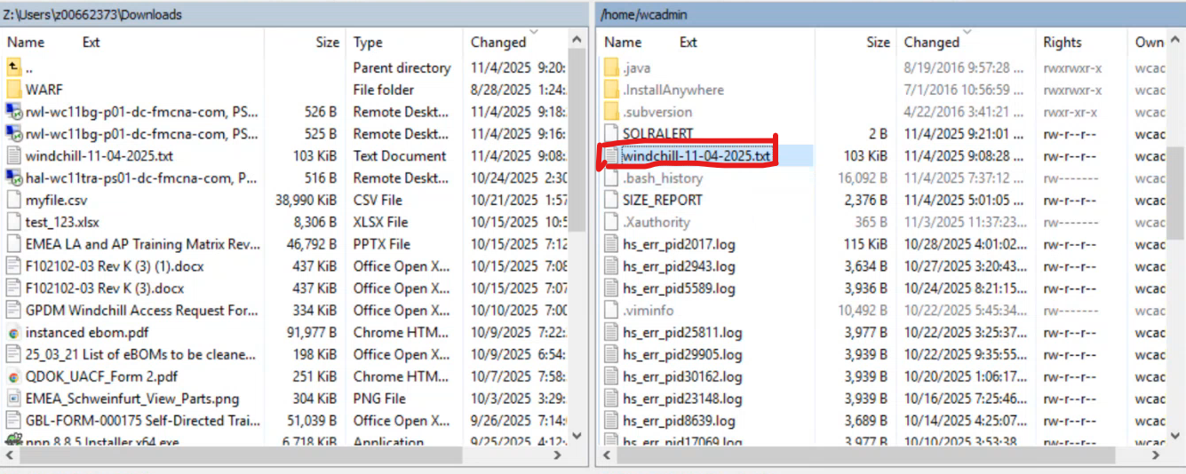
- Once this is done, WinSCP can be closed.

